# Week 4 - Reporting:

In this assignment, my goal is to gain insights into Apple’s financial performance over time by analyzing key aspect such as their financial strength, their net worth, and their management of shareholders’ investment. This information will assist me in understanding the company’s status and trajectory to help with my decision-making regarding potential investment in Apple company. To achieve this, I have chosen three ratios focusing on liquidity, leverage, and profitability. The following summarizes the steps I took and my findings during the Exploratory Data Analysis (EDA) process.

## Data Pre-processing

* Perform an API call to connect to company data on https://www.sec.gov/files/company_tickers.json.
* Perform an API call to retrieve data from company facts, data.sec.gov/api/xbrl/companyfacts/.

For each file obtained from data.set.gov, I investigated the data structure and examine the content. Subsequently, I used Univariate visualization and obtained summary statistics to understand the data structure, identify trends in the data, and assess the need for data cleanup. The following files were what I retrieved and examined data structure to check for any patterns or anomalies in the datasets.

**Revenues file**

Observations:

* This file is comprised of 11 rows of data, covering the end date range from 2015-09-27 to 2018-07-01.
* Columns in this file include, 'start', 'end', 'val', 'accn', 'fy', 'fp', 'form', 'filed', 'frame'.
* The Revenues file has a limited dataset. It only contains data for the period from 2015 to 2018.
* All data contains in this file are filed on the same date, 2018-11-05.
* The Revenues file exclusively contains only data associated with the 10-K form.
* No null or NaN values represent in this file.
* The range of revenue filing is not consistent. After resorting the data by the start date, I observed various data length, ranging from year-long periods to a quarter period. Highlighted below in yellow.

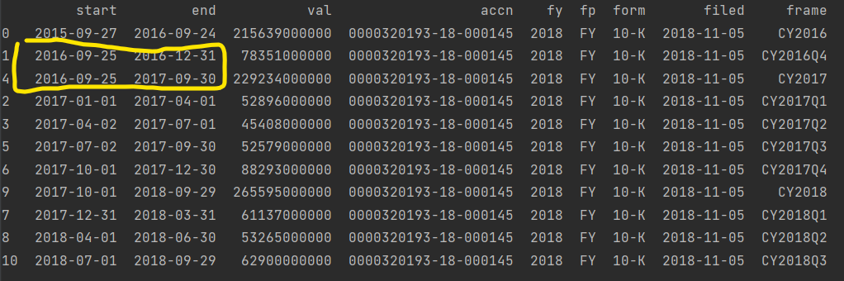

Potential significance

* Need to be careful when analyzing this data due to various data lengths, which can range from yearly or quarterly. The fluctuation in data length could impact data accuracy, potentially skewing the results of our analysis.
* We can merge the revenue data with other datasets but the limitation of this dataset to the 10-K form and the revenue ranged between 2015-2018 will also limit our analysis and finding to only what is available in this file.

**Assets**

Observations:

* This file comprises 124 rows of data, ranging between 2008-09-27 to 2023-09-30.
* Unlike the Revenues file, this file did not have the start date.
* Columns in this file include, 'end', 'val', 'accn', 'fy', 'fp', 'form', 'filed', 'frame'.
* Data entries have varies filing dates.
* Based on the data, accn values appear to represent data filed on each date. (yellow circles below in screenshot).
* Fp and fy columns are aligned with the filed date.
* The file contains forms: '10-K,' '10-Q,' and '8-K.'
* No null data is present in this file.
* The frame column is inconsistent and may contain NaN values.
* Data in different periods can have the same filed date and the same accn values. For example, filed date 2009-10-27 with two different end years – 2008-09-27 and 2009-09-26. Yellow circle.

Potential significance

* When joining this data with other data, it is crucial to verify the end date to ensure data alignment within the same timeframe and should not base data on the filing date.
* We also need to check the length of the data period, as it could be either annual or quarterly data to avoid overstating of assets values.
* Data duplication needs to be removed to avoid overstating the values.

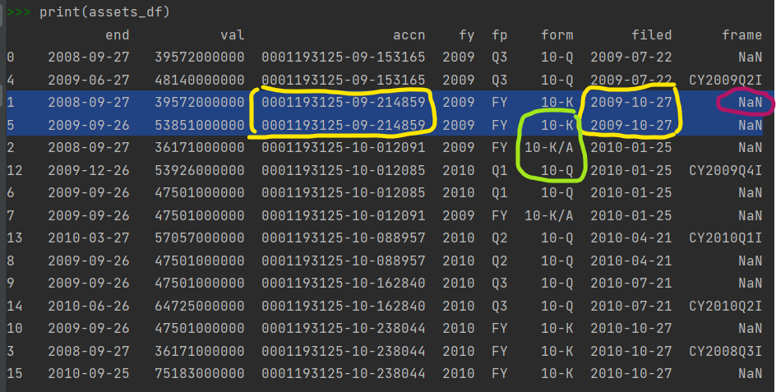

**AssetsCurrent**

Observations:

* This file comprises 122 rows of data, spanning from 2008-09-27 to 2023-09-30.
* Similar to the Assets file, this dataset did not have the start date.
* There are different filing dates.
* This file contains forms: '10-K' '10-Q' '8-K'.
* No null data is present in this file.
* The frame column may contain inconsistencies and NaN values.
* Similar to the Assets file, data in different periods can have the same filing date and the same accn values (Yellow highlight below in the screenshot).

Potential significance

* When analyzing this data, we should filter for a specific form because rows may be duplicated for each form. This will ensure that the analysis focuses on data pertaining to the same form and prevent any potential overstating of assets values.
* When joining this data with other datasets, we need to use the end date. This is to ensure that data from the same timeframe is used and should not based on the filing date.

**Liabilities**

Observations:

* This file comprises 122 rows of data, spanning from 2008-09-27 to 2023-09-30.
* This file shares the same data structure as the Assets file.
* Multiple filing dates are present.
* It contains form '10-Q' '10-K/A' '10-K' '8-K'.
* No null data is present in this file.
* The frame column may contain inconsistencies and NaN values.
* Similar to the Assets file, data in different periods can have the same filed date, resulting in the same accn values.
* The same end date can have different filed date. The value can be the same or different.

Potential significance

* When analyzing this data, it is important to filter for a specific form, as rows may be duplicated for each form. This ensures that the analysis focuses on data related to the same form, which will prevent any potential overstating of liabilities values.
* It is important to check and drop the duplication rows.
* When joining this data with other datasets, we need to check the end date to ensure that data from the same timeframe is used.

**LiabilitiesCurrent**

Observations:

* This file comprises 122 rows of data, spanning from 2008-09-27 to 2023-09-30. This is the same as the previous related files, AssetsCurrent and Liabilities.
* It shares the same data structure as the AssetsCurrent file.
* Multiple filing dates are present.
* Forms included in this file are '10-K/A' '10-Q' '10-K' '8-K'.
* No null data is present in this file.
* The frame column may contain inconsistencies and NaN values.
* Similar to the previous files, data in different period can have the same filing date and the same accn.
* The same end date can have different filed date and the values can be the same or different.

Potential significance

* When analyzing this data, it is important to filter for a specific form to ensure the analysis focuses on data related to the same form. This is to help prevent overstating of liabilities values.
* To avoid duplicate values, it is important to drop the duplicate rows from this dataset.
* When joining this data with other datasets, we need to make sure to check the end date. This ensures that data is from the same timeframe.

**StockholdersEquity**

Observations:

* This file comprises 208 rows of data, spanning from 2006-09-30 to 2023-09-30.
* It shares the same data structure as the other file but does not include the start date.
* Has multiple filing dates present.
* Forms included in this file are '10-K/A' '10-Q' '10-K' '8-K'.
* No null data is present in this file, but the frame column may contain inconsistencies and NaN values.
* The file contains both calendar year data and quarterly data.
* Similar to the previous files, aata in the different periods can have the same filed date.
* The same end date can have different filed date and the frame column may have a value or a NaN value. A screen shot of a computer

  Description automatically generated

Potential significance

* It is important to check for duplicate end dates and values and drop the duplicate rows. This ensures data accuracy and avoids overstating the values due to duplication.
* When analyzing this data, it is important to filter for a specific form. This ensures that the analysis focuses on data related to the same form and prevents any potential overstating of equity values.
* When joining this data with other datasets, it is important to use the end date to ensure alignment of the data. Since the filed date can be the same for different periods, using the end date ensures that data from the same timeframe is used.

**NetIncomeLoss**

Observations:

* This file comprises 302 rows of data, spanning from 2007-09-29 to 2023-09-30.
* It shares the same data structure as the other files and includes the start date.
* Multiple filing dates are present.
* Forms included in this file are '10-K' '10-K/A' '10-Q' '8-K'.
* No null data is present in this file, but NaN values exist in the frame column.
* The file contains both calendar year data and quarterly data.
* Similar to other files, data in different periods can have the same filed date.
* The same end date can have different filed date.

Potential significance

* We can use the start date to calculate the length of the data.
* To avoid duplicate values, it is important to drop duplicate rows.
* When analyzing this data, it is important to filter for a specific form to ensure the analysis focuses on data related to the same form. This can prevent any potential overstating of net income values.
* When joining this data with other datasets, it is important to use the end date to ensure that data are from the same timeframe.

## Data cleaning and wrangling

For each file, the following steps were used to clean up the data.

* Filter for Form 10-K data.
* Sorted data based on the end date and the filed date. This step helps identify the duplicated rows that need to be removed.
* Dropped duplicated row using the end date and retain the latest filed rows.
* Following are the extra steps for the NetIncomeLoss:
* Drop rows with quarterly mentioned in the frame column.
* Calculated the length of our data using both the start date and end date.
* Annual data are kept and quarterly are dropped data where any date length less than 12 months.
* Dropped any remining rows with the same end date.
* Merged the data together using the end date to prepare for ratio calculations.
* Removed unnecessary columns that were not needed.
* Rename columns so it’s easy to understand and read. For example, the “val” column was renamed to “assets”, “liabilities”, “equity”, etc.

These steps described above ensure data quality and prepare data for ratio analysis.

## EDA Exploratory Data Analysis

For each file, I conducted exploratory data analysis using statistical summaries and drew a line graph to gain insights into the trend in the data. The data used in each ratio calculation are analyzed to observe their relationship, pattern, and potential risks or concerns. The same process was applied to analyze each individual ratio.

### Total Assets and Toal Liabilities:

* The highest assets value recorded was approximately $375B and the lowest value was $36B. The average Assets value across the dataset was around $248B.
* The highest liabilities value recorded was approximately $302B and the lowest value was $16B. The average liabilities value across this dataset was around $163B.

* Based on the Assets graph, Apple’s assets exhibited a steady increase from 2010 to around 2017, followed by a slight declined after 2017 until around the end of 2020. Subsequently there was a renewed upward trend after 2021. However, it has not reached the peak value observed in 2017.
* Apple’s assets and liabilities moved in the same direction and align, as assets increased, so did liabilities.

### Current assets and Current liability

* The highest recorded value for current assets was approximately $162B and the lowest value was around $32B. The average current assets value was around $95B.
* The highest recorded current liabilities value was approximately $154B and the lowest value was $12B. The average current liabilities value was around $77B.

* Based on the current assets graph, Apple’s current assets show a consistent YoY increase, peaking around the end of 2019. However, it subsequently experienced a decline until approximately the end of 2022 to early 2023 when a gradual recovery began. This pattern indicates a reduction in assets that can be converted into cash within one year, coinciding with an increase in current liabilities.
* Apple’s current liabilities, as shown in the graphs, also generally moved upward in tandem with their current assets. Noticeable drop around the end of 2018, aligning with a sharp increase in their current assets. However, in 2021, their current liabilities surpassed their current assets. This raised concerns as it indicated a potential decrease in available net assets for operating activities.
* According to the graphs, Apple’s working capital showed a decrease around the end of 2014-2015. This signifies a period with company financial were less stable but still have more current assets than current liabilities.
* Their working capital in 2022 turned negative which signals potential liquidity issues and challenges in meeting short term obligations. This shift raises concerns about the company’s ability to cover its short-term liabilities with their available short-term assets.
* According to ABC News (2022), Apple’s shares experienced a significant plunge, which coincide with the company’s negative working capital we saw above. The combination of the financial indicator I saw, and the news raises concerns about Apple’s financial stability. As this data represents historical information, ongoing monitoring is needed to assess whether Apple’s financial trajectory undergoes any changes in the following year.

### Total liabilities and Equity

* The highest total liabilities value recorded was approximately $302B and the lowest value was $15B. The average total liabilities value across the dataset was around $163B.
* The highest equity value recorded was around $134B and the lowest value was $22B. The average equity value was approximately $85B.

* According to the graph, Apple’s total liabilities show an upward trend, consistently increasing YoY. This indicates a growing financial obligation for the company, which could potentially impact on their financial health and leverage.
* The equity graph reveals an increase until around the end of 2012, followed by a period of stability until the end of 2017. However, a decline occurred after 2018, and this drop in equity could potentially be attributed to the pandemic situation. This is also raising some concern as the shareholders’ equity indicates the company’s net worth and it appears to be declining.

### Net Income and shareholders’ equity

* The highest net income value recorded was around $998B and the lowest value was $61B. The average net income value was around $490B.
* The highest equity value recorded was around $134B and the lowest value was $22B. The average equity value was around $845B.

* According to the graph, Apple’s net income appears to increase gradually until around the turn of 2020-2021. There was a significant spike in the following year, followed by a seeming plateau in the latest data.
* The observed spike in net income during 2020-2021 doesn’t appear to be sustained as it is plateauing in the following year. This pattern suggests that this increase could be influenced by an event or set of circumstances specific to that timeframe.
* We should continue monitoring to observe the plateau period, as it may have implications for investor confidence and the overall perception of Apple’s financial performance.
* Apple’s shareholders’ equity experienced a sharp increase between 2009-2013, however, there is noticeable variance in their shareholders’ equity in the following year.
* The period from the end of 2012 to the end of 2013 shows minimal change, followed by a dip in 2014. Subsequently, there is a renewed upward trend until the end of 2017, followed by a decline again until the end of 2019. The fluctuation in Apple’s shareholders’ equity raises a few potential concerns on their financial health.

### Financial Ratios

#### Current Ratio (Current Assets / Current Liabilities)

Apple’s current ratio shows a downward trend. Until 2022, Apple appears to be able to maintain their current ratio above 1 indicates that they had sufficient liquid assets to cover for short-term debt and other payables. However, the subsequent decline and the drop below 1 after 2022 that I observed coupled with my earlier analysis and concerns about their current assets and current liability, raise server concerns. These concerns encompass Apple’s ability to meet short-term obligations with their existing liquid assets, concern on the short-term solvency risk, the concern on their negative working capital which impact their ability to fund the day-to-day operations, and the implications for operational efficiency in managing their current assets and current liabilities.

* Debt-to-Equity Ratio (D/E) (Total Debt/ Total Equity)

According to the above graph, I observed a steady increase in Apple’s Debt-to-Equity ratio between 2013 to the end of 2022. This suggests that Apple is in a risky financial position, with their liabilities increasing in every dollar of shareholders’ equity. This trend could be interpreted as Apple having a less stable capital structure or a reduction in solvency, indicating an increasing reliance on external liability relative to equity. When coupled this analysis with my earlier observations of their total liabilities and shareholders’ equity, they signal an increase of their financial risk as their proportion of financing coming from external sources. The reduction in solvency raises concerns about their ability to cover their obligations from their equity. In summary, the analysis from D/E ratio deepens my concerns about Apple’s overall financial health and stability.

### Return on Equity (Net Income / Shareholder Equity )

Apple’s Return on Equity remained relatively flat between 2009 to the end of 2017. Subsequently, there was an uptick, and a significantly increased in their ROE from around 2018 to the end of 2022. This indicated that Apple performed very well during these four years, as the increase in ROE demonstrates the ability of Apple in efficiently turn shareholder equity into net income and effectively use their equity capital to generate profits. However, the drop after 2022 signal risk in Apple’s financial health. We need to continue monitoring their financial status to assess whether this trend will persist, look for a signal of potential sustained decline, and whether Apple can reverse the trend and increase their ROE in the following year.